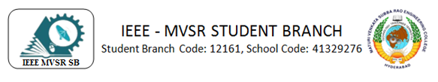
IEEE XTREME 17.0 AWARENESS SESSION
The IEEE CS MVSR Student Branch conducted an awareness session on the prestigious IEEE Xtreme Global Hackathon, in collaboration with IEEE-CS Hyderabad Section. It is set to be held in the third week of October, on 28th. The speaker for the session was Sai Charan Emmadi, an MVSR alumni and IEEE Young Professional and a decorated veteran of previous editions of IEEE Xtreme. The session took place with the presence of Dr. D Hari Krishna, IEEE MVSR SB Counsellor along with Mr. Vijay Krishna, IEEE CS Hyderabad Secretary as the chief guest.
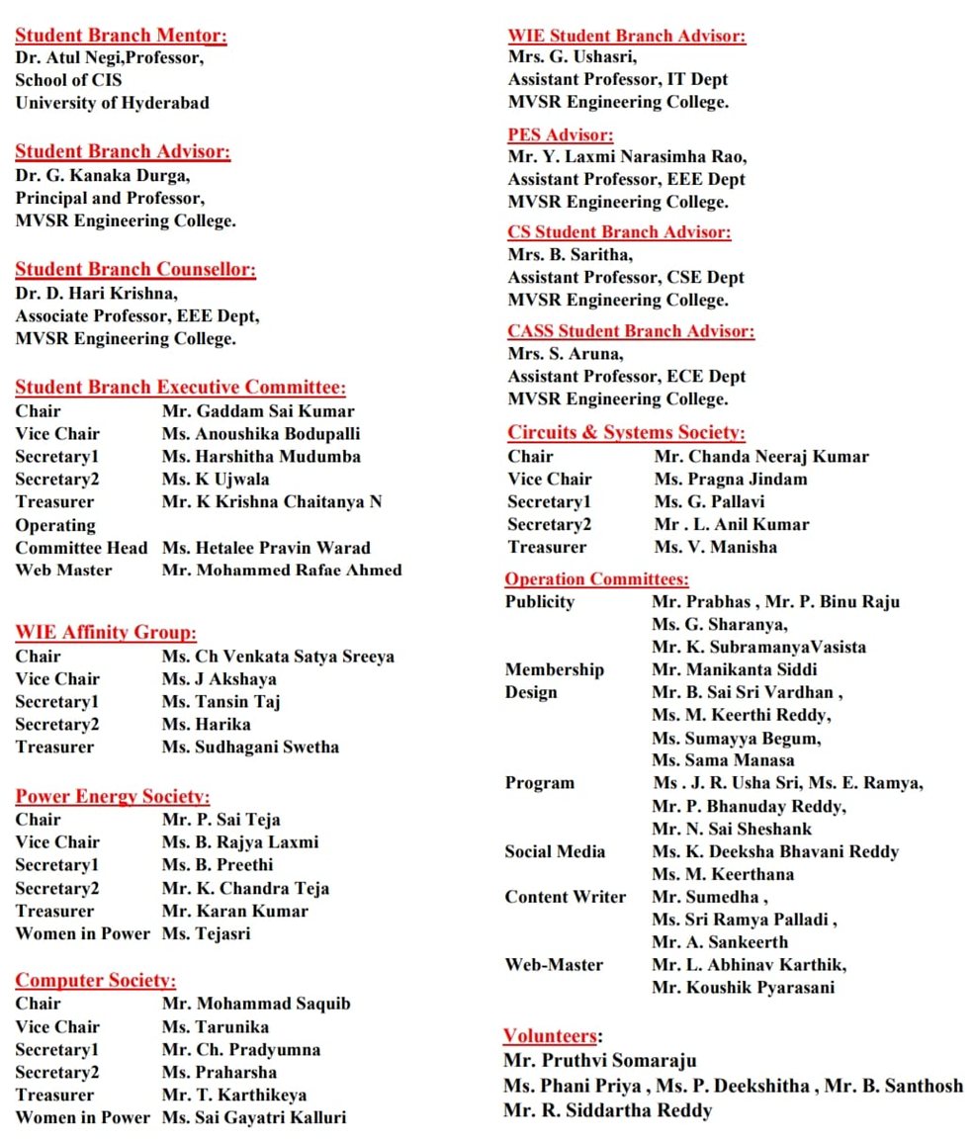

Session Details:
Date: 6nd Oct 2023
Timings: 6:30 - 8:30 PM
No.of Attendees : 27
Description:
The students of IEEE CS MVSR conducted an awareness session on IEEE Xtreme, the global hackathon which is held every year in the third week of October. The speaker for the session was Sai Charan Emmadi, an alumni of MVSR and a IEEE Young Professional, who has had a stellar performance in the previous editions of IEEE Xtreme.
The meeting started with IEEE MVSR CS Chair Mohammad Saquib who encouraged all students to participate in the global hackathon to improve their coding skills. He introduced the students to Sai Charan Emmadi, who would guide the students regarding how to participate in the hackathon.
Mr Vijay Krishna, IEEE CS Hyderabad Secretary, who served as the chief guest for the session, then appreciated the efforts of IEEE MVSR Student Branch, for conducting such events which promoted the participation of students in IEEE events. He also spoke about the importance of real-world experience in today’s growing market, and how the Hyderabad section stands in the Top 5 sections with the highest registrations for this hackathon. He congratulated Dr D Harikrishna, IEEE MVSR SB Counsellor and Ms. Saritha Bantu for fostering an environment which encouraged students to enhance their skills. He commended IEEE Executive Committee members for their volunteering efforts as well and wished all students to perform well in the hackathon.
Sai Charan, IEEE Young Professional then proceeded to give the attending students a high-level overview about the prestigious global hackathon and his previous experience in participating in the hackathon. He provided many insights to the students not only coding related, but certain practices and general advice which would help the students better tackle the challenging 24-hour hackathon. The session also included the topics one must be aware about, the general pattern, the important topics one has to be aware of, data structures and algorithms, and other topics like dynamic programming and recursion which would elevate the rank of the students participating in the hackathon.
Sai Charan also discussed a few sample questions and general approaches to solve such questions in the hackathon. The session was very interactive with students contributing to the discussion by suggesting different approaches to tackle the challenging questions.
Sai Charan’s insights as a former participant were especially informative, which included how to better navigate the hackathon, how to perform to one’s strengths. He encouraged everyone to make use of IEEE’s resources to better prepare for the hackathon, in addition to solving problems on coding platforms.
His words were not only applicable for this event, but all future hackathons and coding rounds that a student would be subjected to in their academic and professional career. In fact, in the process of preparing for this hackathon, a student would become adept at solving coding questions and would be better prepared to crack challenging company interviews as well.
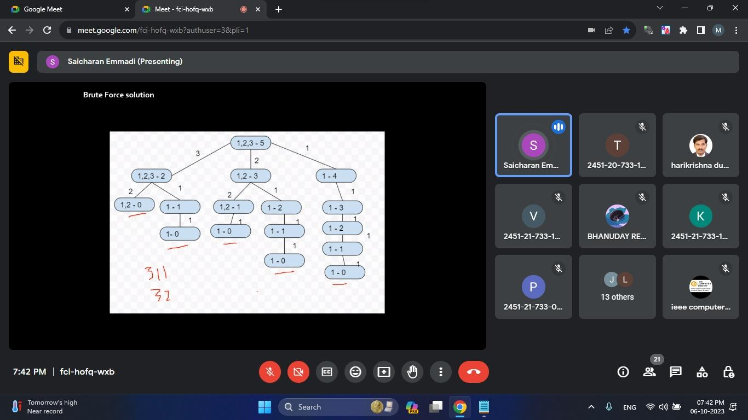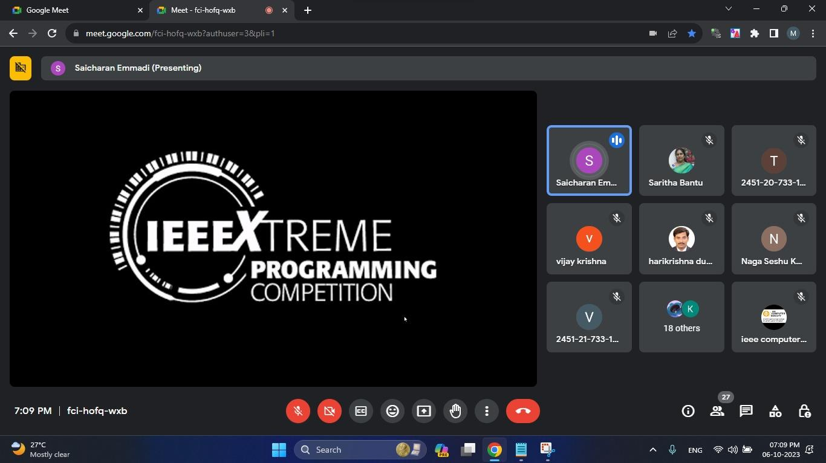
Slides presented in the meeting

IEEE MVSR CS Vice Chair, T Tarunika, then proposed to organize a 24-hr mock- hackathon for the students of MVSR in the week leading up to IEEE Xtreme, which would simulate the hackathon in real life, and would enable the students to get adjusted to the challenging environment of the hackathon.
The program ended on a high note with a vote of thanks by IEEE CS Chair, Mohammad Saquib, and the students were excited to apply their new-found knowledge and win laurels in IEEE Xtreme 17.0 edition.

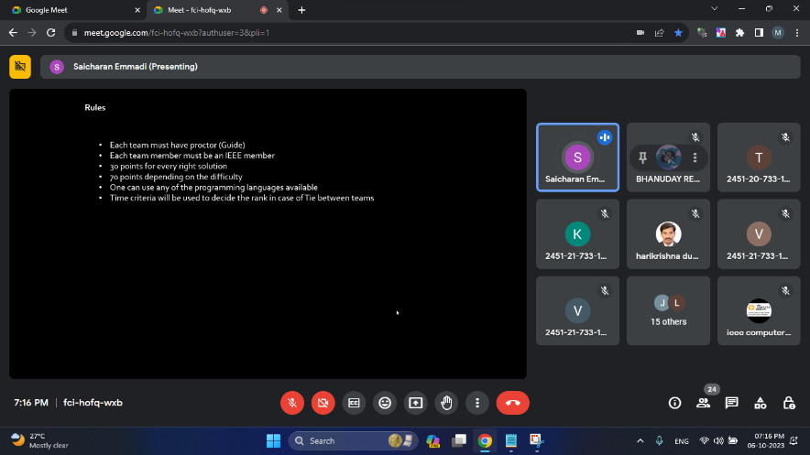

Slide presented in the meeting

List of Attendees:
S.NO | Name of the Participant | Roll Number | IEEE ID
1. | Dr. D. Harikrishna | Faculty
2. | Mrs. B. Saritha | Faculty
3. | Sai Charan | Speaker
4. | Naga Sheshu Kodali | Ambassador Xtreme 17.0
5. | Vijay Krishna | GNITS Faculty
6. | Gaddam Sai Kumar | 2451-20-735-069 | 98196838
7. | Anoushika Boddupalli | 2451-20-733-037 | 98196593
8. | Mohammad Saquib | 2451-20-733-132 | 97496648
9. | T Tarunika | 2451-20-733-149
10. | Chacham Pradyumna | 2451-21-733-066 | 99228779
11. | Nelaturi Praharsha | 2451-21-737-170
12. | Thimirishetty Karthikeya | 2451-20-733-152
13. | Kalluri Sai Gayathri | 2451-21-733-118
14. | Mohammed Rafae Ahmed | 2451-20-733-162
15. | Koushik Pyarasani | 2451-21-733-083 | 99228518
16. | Sumayya Begum | 2451-20-733-025
17. | Akshaya Jureddy | 2451-20-735-064 | 99216652
18. | L Abhinav Karthik | 2451-21-733-009
19. | Bhanu Uday
20. | Mehraj Fatima | 2451-20-733-139
21. | Siva Datta | 2451-20-733-124

Reported by IEEE MVSR SB

